Software Requirements Specification

for

Machine Learning in Diabetes

Version 1.0

Prepared by

KHUSHI NARUKA

1.INTRODUCTION

DOCUMENT PURPOSE: TO DETECT IF THE PERSON IS SUFFERING FROM DIABETES USING GLUCOSE AND BLOOD PRESSURE AS FEATURES AND DIABETES AS LABEL.

PRODUCT SCOPE: HELPS TO CHECK IF A PERSON HAS DIABETICS

INTENDED AUDIENCE: DEVELOPER, TESTER

2.OVERALL DESCRIPTION

PRODUCT OVERVIEW:

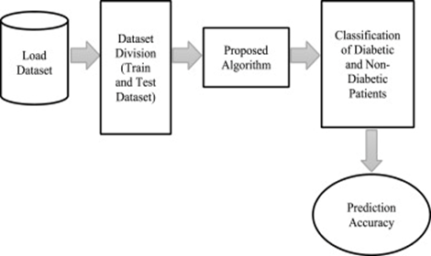

PRODUCT FUNCTIONALITY:

R1: Download data in CSV format

R2: Using pandas extract features and label from CSV file

R3: Build ML Model using ML Algorithm

R4: Predict and analyse

3.FUNCTIONAL REQUIREMENTS

Using pandas extract features and label from CSV file

Build ML Model using ML Algorithm

4.OTHER REQUIREMENTS